afghan village model
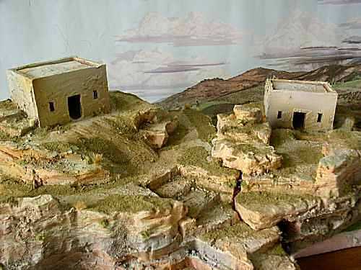
http://theminiaturespage.com/workbench/752580/

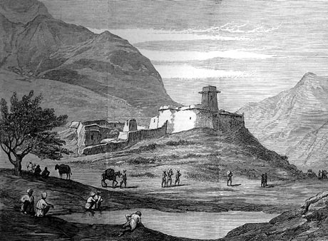
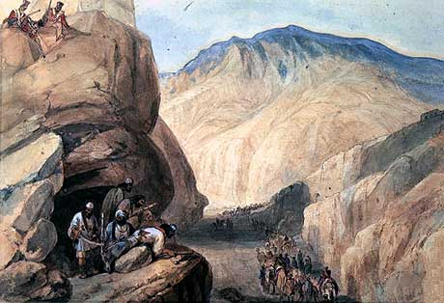
http://www.britishbattles.com/first-afghan-war/kabul-1842.htm

photos:
http://www.tajiktraveller.com/jeep.html

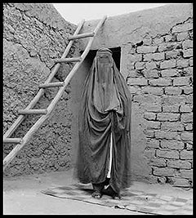

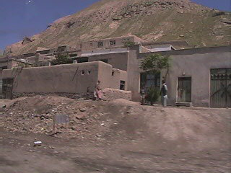

http://bobbybran.blogs.com/photos/afghan_people/mud_house.html

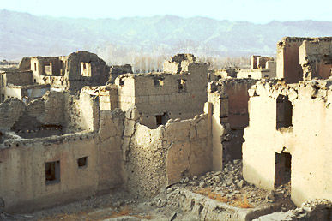
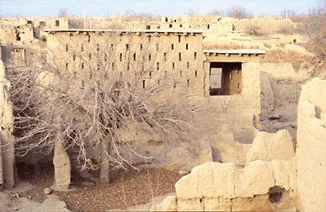
http://www.un.org.pk/latest-dev/UXO-blues/images/18_103-08_jpg.jpg

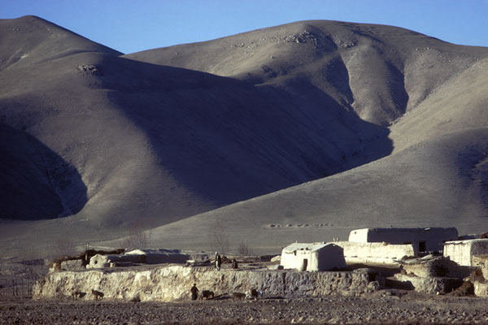
http://avalon.unomaha.edu/afghan/afghanistan/A14.HTM

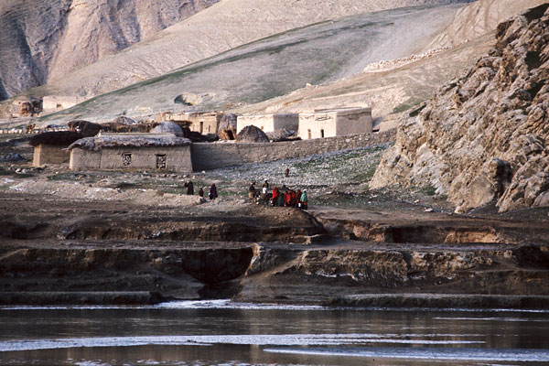
http://avalon.unomaha.edu/afghan/afghanistan/A25.HTM

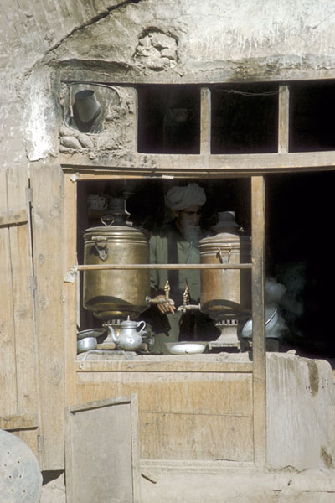

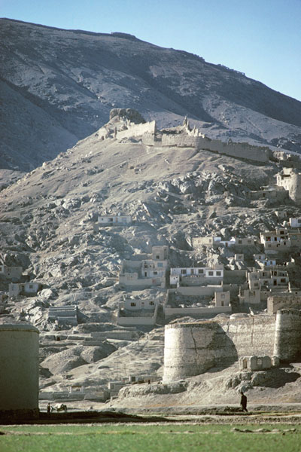
http://avalon.unomaha.edu/afghan/afghanistan/kabul/ak01.htm

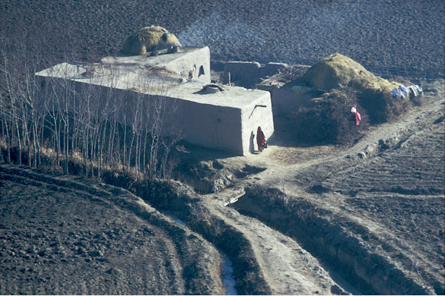
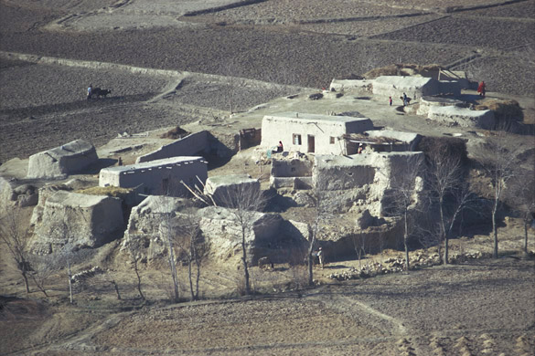

Swat river valley:

http://avalon.unomaha.edu/afghan/pakistan/swat/sw01.htm

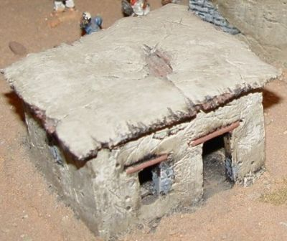

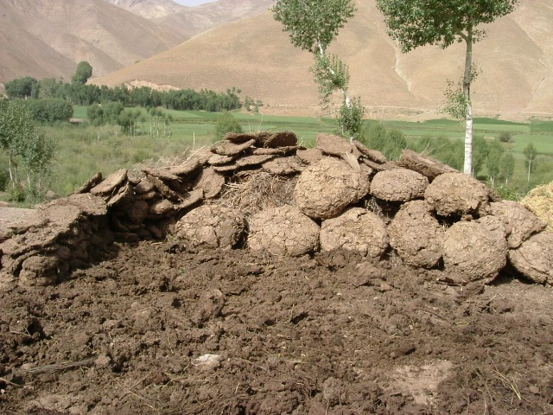

Dung heaps for fuel
http://vasco-pyjama.livejournal.com/tag/afghanistan

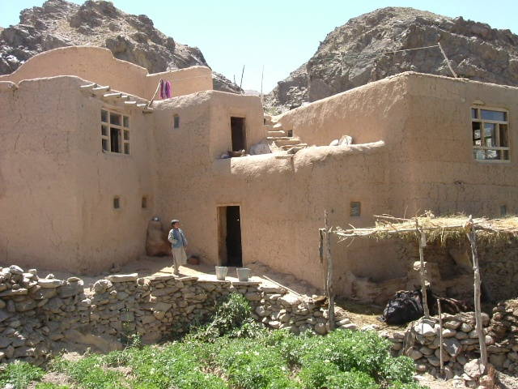

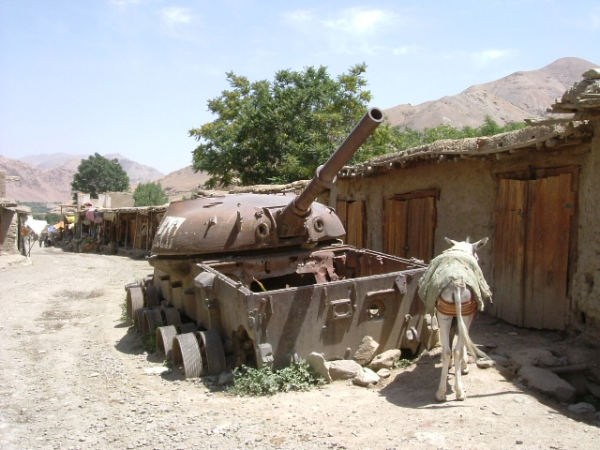

http://www.zeitcom.com/majgen/

http://www.zeitcom.com/majgen/39howst.html

Jeff Jonas
Sony Online Entertainment LLC
Artist FreeRealms
www.ancientbattles.com

